**CM1605 Web Technology**

**Tutorial 8**

The aim of this tutorial is to make use of HTML web accessibly techniques to improve accessibility of web pages, use correct color scheme combinations and familiarize with web accessibly evaluation tools.

This is an individual exercise. You may use any text editor (Notepad, Notepad ++) to create/modify the HTML pages and any Browser application (chrome, IE, firefox etc) to run the web pages.

**Part A**

Visit the following websites: Discuss your opinions on the given aspects with your tutor.

* <http://www.pnwx.com/>
  + What is the first impression?
  + What is the target audience?
  + How do you find the design theme used?
  + What do you think of the typography (font style, size etc)
  + Color pallette used?
  + How easy to navigate the website?
* <http://www.roverp6parts.com/?LMCL=NVW5tl>
  + What is the first impression?
  + What is the target audience?
  + How do you find the style used?
  + What do you think of the consistency of website? (look for the aspects of logo, colors pallette)

**Part B**

The following is a web GUI of an intelligent employment recommendation system which recommends employment opportunities.

1. Modify the startup.html file to use HTML web accessibility tags and techniques discussed in the lecture to improve the accessibility of the web site by screen readers.
2. Make sure to apply the correct tags that convey the content structure and hierarchy
   1. Text – use of titles, language, headings,
   2. Images – alternative texts
   3. Forms – implicit labels, grouping, required fields
3. Style the page with your own set of color contrast scheme. Refer [Color wheel - color theory and calculator | Canva Colors](https://www.canva.com/colors/color-wheel/)

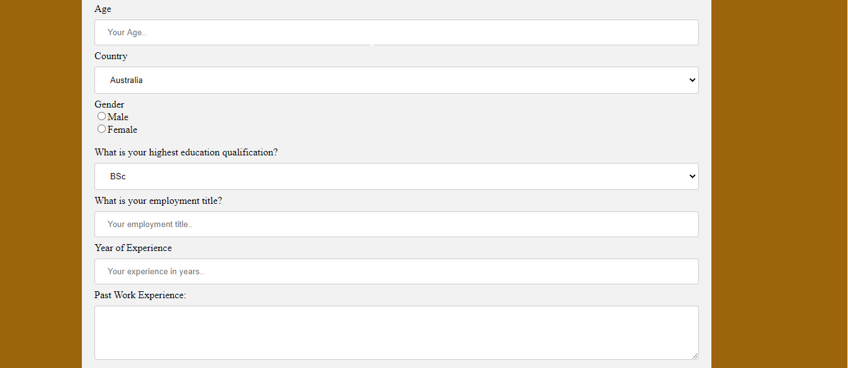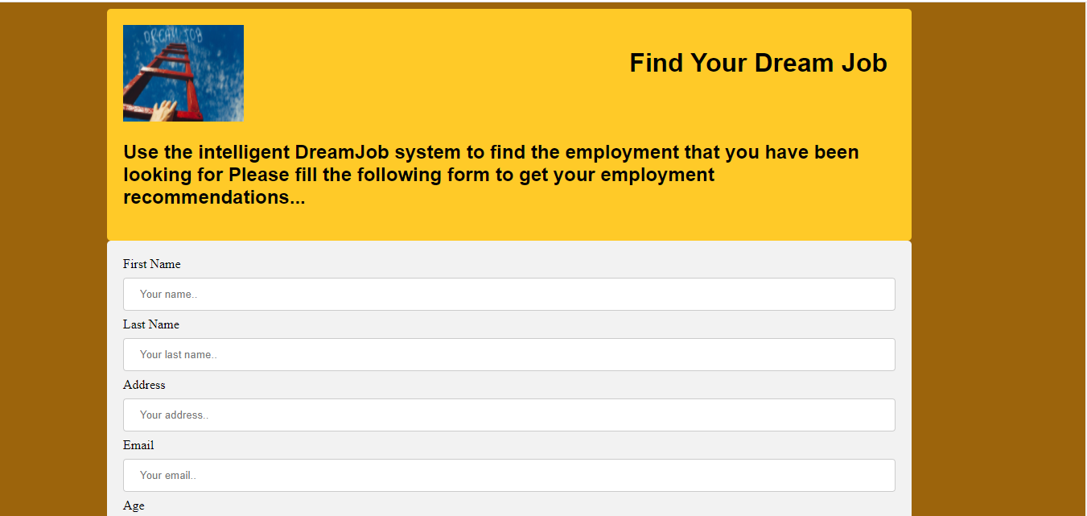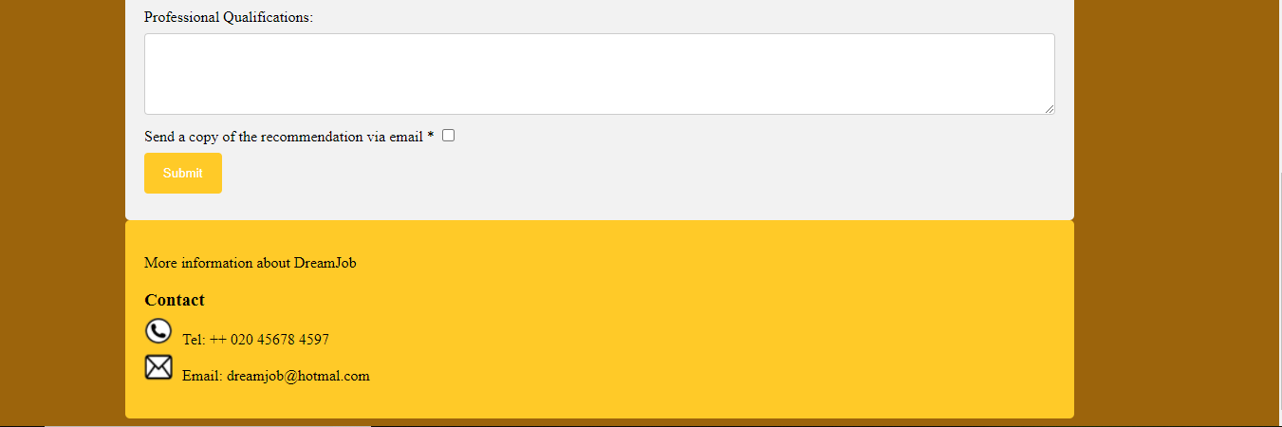

**Part C**

1. Once you complete your work check the web page with the ‘**wave’** accessibility evaluation tool. (Note: install the wave browser plugin preferably chrome/Firefox to evaluate accessibility of the local html files). [WAVE Web Accessibility Evaluation Tool (webaim.org)](https://wave.webaim.org/).
2. To make sure that the UI elements in the web page modified have the right color contrast using ‘**snook.ca’**. [Colour Contrast Check - snook.ca](https://snook.ca/technical/colour_contrast/colour.html#fg=33FF33,bg=333333)
3. Based on the reports correct the design of your web page to address possible errors that you get from the web page accessibility and color contrast evaluation tools until you achieve a good accessibility report.